

**Parishes and communities working together.**

**Community or group**

Weston Colville, Cambridgeshire

**Address**

Weston Colville, Cambridgeshire

**Which Environment Agency flood warnings are you registered to receive?**

Flood warnings for Weston Colville not currently available.

See Flood Risk website:

www.gov.uk/check-flood-risk

**Date**

31 August 2022

Heavy persistent rainfall, snowfall/ high water level in local streams (Stour Brook and tributaries) and ditches. Water cascading along Chapel Road and down north and south sides of Mill Hill.

**Local flood warning trigger**

**Floodline Quickdial Number**

0345 988 1188

**Contents**

1. **Actions to be taken before a flood.**

**A - Locations at risk of flooding: flood warnings**

**B - Locations at risk of flooding: locations at risk of flooding / sources of flooding**

**C - Locations at risk of flooding: map showing direction of flooding**

1. **Actions to be taken during a flood.**

**A - Local flood actions**

**B - Local volunteers / flood wardens**

**C - Important telephone numbers**

**D - Available resources**

**E - Arrangements between authorities**

**F - Vulnerable residents, properties and locations**

1. **After a flood**

**A - Reputable contractors**

**1A – Locations at risk of flooding:** Flood warnings

From the information you have available, make a list of areas liable to flood and the level of warning which would affect them.

|  |  |  |  |
| --- | --- | --- | --- |
| **Area number** | **Location of risk** | **Trigger level** | **Actions** |
| Area 1 | Church End/ New Terrace Cottages  Junction of Mill Hill and Brinkley Road | Heavy persistent rainfall, surface water running down Mill Hill | 1.Ensure gullies, pots, and drains on the north side of Mill Hill are kept clear and are maintained to allow free flow of water away from the road surface.  All issues relating to water on the highway or blocked gullies should be reported to Highways via highways@cambridgeshire.gov.uk, the online reporting tool or 0345 045 5212.  2.Alert owners of vulnerable properties in the event of severe rainfall events and provide support if necessary.  3.Monitor the proposed work at Church End to mitigate flooding by installing more extensive gully/grid drainage system in the road just before New Terrace cottages.  4. Ensure information on supplying sandbags/hydrosacks to affected properties is available. |
| Area 2 | Area around the Reading Room – village end of Mill Hill and junction with Chapel Road. | Heavy persistent rainfall and high-water level in Stour Brook tributary stream | 1.Ensure gullies pots and drains on the south side of Mill Hill are clear and maintained to allow free flow of water from the road surface.  All issues relating to water on the highway or blocked gullies should be reported to Highways via highways@cambridgeshire.gov.uk, the online reporting tool or 0345 045 5212.  2. Ensure grips and drains in the area around the Reading Room are kept clear and regularly maintained.  3. The tributary of the Stour Brook that runs under the road by the Reading Room needs regular maintenance from the road down by the recreation ground to the ford at Clamps Lane. The two drainage pipes running under the road to join the ford represent a bottleneck for water flow.  4. Ensure information on supplying sandbags/hydrosacks to affected properties is available. |
| Area 3 | Chapel Road | Heavy persistent rainfall causing overflow of drains and ditches/ high water level in Stour Brook tributary stream. Water cascading down Chapel Road | 1. Ensure gullies, pots, and drains on the North side of Chapel Road are kept clear and maintained to allow free flow of water from Chapel Road.  All issues relating to water on the highway or blocked gullies should be reported to Highways via highways@cambridgeshire.gov.uk, the online reporting tool or 0345 045 5212.  2 Ensure all drains, ditches, and pipes along North and South sides of Chapel road are kept clear and regularly maintained from the Chapel down to the Reading Room.  3 Ensure that all ditches to the West of  Chapel Road beyond the Chapel are regularly cleared and maintained to allow free flow of water.  4 Ensure cuts into the ditches to the west of the Chapel Road beyond the Chapel are clear to allow water to drain into the ditches from the road. There are approximately 40 cuts from the road into the ditches from the Chapel going west to the end of the 40-mph restriction zone which should be kept clear. Ensure all drainage pipes in the ditches to the west of the Chapel are kept clear to allow free flow of water.  5. Ensure information on supplying sandbags/hydrosacks to affected properties is available. |
| Area 4 | Common Road between Applerose Cottage and Thorseby | Heavy persistent rainfall, run-off from adjacent fields.  Flooding from the Stour Brook. | 1.Regular clearance and maintenance of grips from the road into the ditches up from 71/72 Common Road. (look out for 11,00kv electricity cable just below surface of the verge).  2.Permanent drains and ditches in area need cleaning out and maintained as required but at least on an annual basis.  3.Bridge across Stour Brook east of College Farm in danger of collapse and blocking the stream.  4. Regular maintenance and clearance of the Stour Brook that runs alongside Common Road by riparian owners. |
| Area 5 | Horseshoe Lane/Clamps Lane Ford. | Arrangement of the ford at this site causes restriction to water flow that affects flooding on Common Road upstream. | 1. Repositioning of the bridge has taken place and regular downstream clearance of the watercourse is required (Stour Brook).  2. Regular clearance of the Stour Brook downstream from the ford by riparian owner. At least on an annual basis. |
| Area 6 | On B1052 at Church End just to the east of Hall Farm | Heavy persistent rainfall causing overflow of ditches and drains mainly on the south side of the road adjacent to Hall Farm and in front of the houses on the south side of the road. | Regular clearance of the ditches and drains by riparian owners and maintenance of the grips through the verge into the ditches. Clearance of the drainage pipe under the B1052. |

**1B – Actions to be taken before a flood:** Locations at risk of flooding / source of flooding.

Insert details of areas at risk from flooding and the direction of flooding. Include maps and if possible, details of existing defences.

|  |  |  |  |
| --- | --- | --- | --- |
| **Area number** | **Location at risk** | **Source of flooding** | **Direction of flooding** |
| Area 1 | Church End/ New Terrace Cottages  Junction of Mill Hill and Brinkley Road | Surface water from heavy rainfall flowing down the north side of Mill Hill towards the junction with Brinkley Road | Down the North side of Mill Hill into Brinkley Road |
| Area 2 | Area around the Reading Room – village end of Mill Hill and junction with Chapel Road. | Surface water from heavy rainfall flowing down the south side of Mill Hill towards the Reading Room and the junction with Chapel Road.  Possibly breaching of the banks of the tributary of the Stour running under the road by the Reading Room. | Down the south side of Mill Hill towards the Reading Room. |
| Area 3 | Chapel Road | Surface water from heavy rainfall flowing down Chapel Road in drainage ditches, pipes, and overflowing gullies | Mainly eastwards down Chapel Road |
| Area 4 | Common Road | Surface water following heavy rainfall accumulating in the road and causing flooding. | Mainly northwards towards the village. |
| Area 5 | Horseshoe Lane/Clamps Lane Ford | Stour Brook very high following heavy rainfall. | Stour Brook flowing in northerly direction. |
| Area 6 | On B1052 at Church End just to the east of Hall Farm | Surface water following heavy rainfall accumulating in the road and causing flooding | Ditches and drains in the area have insufficient capacity and overflow onto the road. |

**1C – Actions to be taken before a flood:** Maps showing areas susceptible to flooding.

For maps of long-term local flood risk visit [www.gov.uk/check-flood-risk](http://www.gov.uk/check-flood-risk) and enter a post code **or view maps in Appendix 2.**

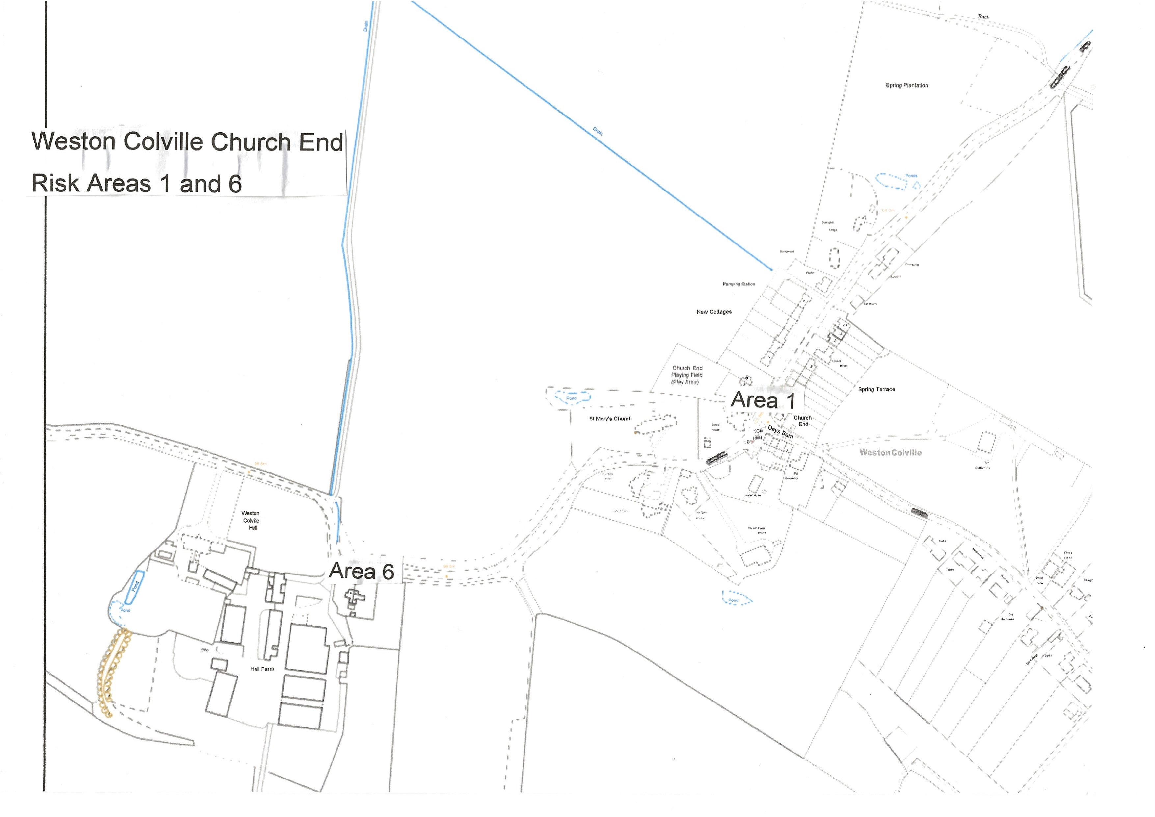

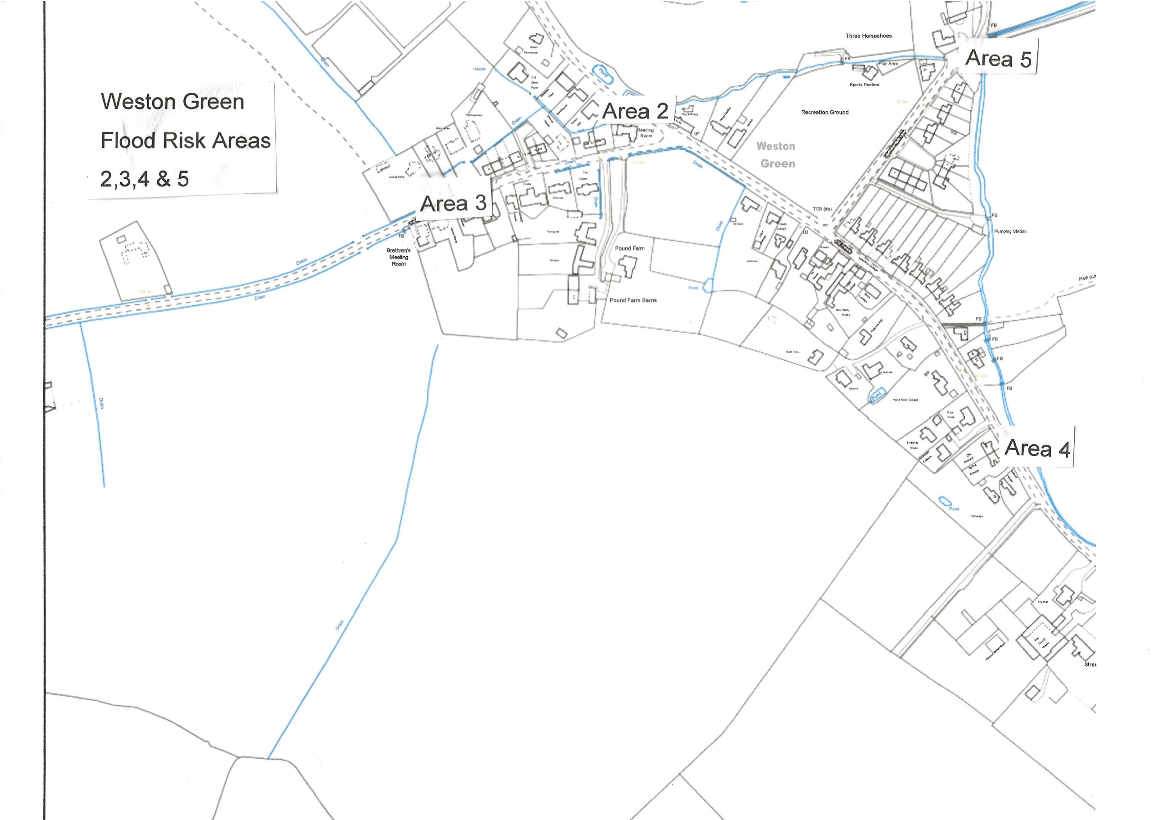

**2A – Actions to be taken during a flood:** local flood actions.

Identify local flood actions.

|  |  |  |  |  |  |
| --- | --- | --- | --- | --- | --- |
| **Area number** | **Location at risk** | **Action / trigger** | **Local action** | **Equipment required** | **Time required** |
| Area 1 | Church End/ New Terrace Cottages  Junction of Mill Hill and Brinkley Road | Water flowing down north side of Mill Hill and into Brinkley Road after persistent heavy rainfall. | Alert residents of problem including by local Flood Warden | Sandbags/hydrosacks – located in black ‘grit’ bin by the fence behind the phone box at Church End | At time of flooding incident  Sandbags/hydrosacks available prior to flooding incident. |
| Area 2 | Area around the Reading Room – village end of Mill Hill and junction with Chapel Road. | Water flowing down south side of Mill Hill after persistent heavy rain. | Alert local residents of problem including by local Flood Warden.  Flood warning signs in position for motorists | Flood warning signs.  Sandbags/hydrosacks – located behind the bus shelter by the Reading Room | At time of flooding incident  Sandbags/hydrosacks available prior to flooding events. |
| Area 3 | Chapel Road from Chapel to junction with Mill Hill | Water flowing down Chapel Road from west to east following persistent rain events. | Alert local residents including by local Flood Warden.  Flood warning signs in position for motorists | Flood warning signs  Sandbags/hydrosacks – located behind the bus shelter by the Reading Room | At time of flooding incident.  Sandbags available prior to flooding incident |
| Area 4 | Common Road and local properties, particularly to the west of Common Road. | Road flooded after persistent heavy rain | Alert local residents of problem including by local Flood Warden.  Flood warning signs in position for motorists | Flood warning signs.  Sandbags/hydrosacks – located behind the bus shelter by the Reading Room | At time of flooding incident.  At time of flooding  Sandbags available prior to flooding incident |
| Area 5 | Clamps Lane/Horseshoe Lane Ford | Water level very high in ford area of Stour Brook | Alert local residents of problem including by local Flood Warden.  Flood warning signs in place for motorists | Flood warning signs | At time of flooding incident. |
| Area 6 | On B1052 at Church End just to the east of Hall Farm | Road flooded after persistent heavy rain | Alert local residents of problem including by local Flood Warden.  Flood warning signs in place for motorists | Flood warning signs | At time of flooding incident |

**2B – Actions to be taken during a flood:** local volunteers / flood wardens.

List local volunteers/flood wardens that could be contacted in an incident. They may be required to lift heavy sandbags so should be reasonably active or fit. Consider using other volunteers such as communicators, administrators, or minders of vulnerable people during an incident. These volunteers could be registered on the Environment Agency’s Floodline Warnings Direct service, so they receive the flood warnings. **Volunteers must not put their own life at risk.**

|  |  |  |  |  |
| --- | --- | --- | --- | --- |
| **Name** | **Address** | **Telephone Day** | **Telephone Evening** | **Mobile** |
| Bridget Durham |  |  |  | 07790705821 |
| John Garrod |  |  |  | 07776061492 |
| Faye Parker |  |  |  | 07815608897 |
| Peter White |  | 01223 290160 | 01223 290160 | 07757257530 |
| Alastair Douglas |  | 01223 291475 | 01223 291475 | 07981490475 |
|  |  |  |  |  |
|  |  |  |  |  |
|  |  |  |  |  |
|  |  |  |  |  |
|  |  |  |  |  |

**2C – Actions to be taken during a flood:** Important telephone numbers

Make a list of important telephone numbers so all the information you require during an incident is readily available.

|  |  |  |  |
| --- | --- | --- | --- |
| **Organisation** | **Telephone (office hours)** | **Telephone (out of hours)** | **Fax** |
| **Floodline** | 0345 988 1188 |  |  |
| **Environment Agency** | 0800 807060  Incident hotline |  |  |
| **District Council** | 03450 450 063 |  |  |
| **County Council** | 0345 045 5212 (Highways Agency for flooding issues) |  |  |
| **County Contracting** |  |  |  |
| **Fire & Rescue Service** | 999 |  |  |
| **Police** | 999 |  |  |
| **Ambulance Service** | 999 |  |  |
| **Housing Unit** |  |  |  |
| **Environment Unit** |  |  |  |
| **Water Company** | 01223 706050  Cambridge Water |  |  |
| **Electricity Company** |  |  |  |
| **Gas Company** |  |  |  |
| **Telecommunications Company** |  |  |  |
| **Adjacent Town/Parish Councils** | West Wratting  Brinkley  Carlton  West Wickham |  |  |

**2D – Actions to be taken during a flood:** Available resources

Identify available resources.

|  |  |  |  |  |
| --- | --- | --- | --- | --- |
| **Organisation** | **Resource** | **Number** | **Location** | **Notes** |
| Cambridgeshire County Council | The rights and responsibilities of a riparian owner | e-mail: floodand water@cambridgeshire.gov.uk |  | Leaflet available from Cambridgeshire County Council |
| Weston Colville Parish Council | The Parish Council has acquired a stock of hydrosacks and hydrosnakes which perform the function of sandbags when activated in contact with water.  These are located in black ‘grit’ bins, one behind the bus shelter by the Reading Room and the other by the fence behind the phone box at Church End.  The grit boxes are locked for security purposes but can be opened by any of the Flood Wardens listed above or by members of the Parish Council.  The Parish Council has also acquired a set of drain rods, a submersible pump to assist in the event of a property becoming flooded and some road signs to indicate when a section of a road in the village becomes flooded. These will be deployed by the Flood Wardens as appropriate. |  |  |  |
| South Cambs District Council for  sandbags/hydrosacks/aquasacks | It is recommended that property owners at risk of flooding make their own arrangements for sandbags/hydrosacks in advance of flooding. Residents can purchase sandbags and sand from builders merchants or DIY stores. You may also find further help from South Cambs District Council. Depending on the scale of flooding around the district, their resources may be seriously stretched and supplies of sandbags/hydrosacks may be limited and slow delivery timescales could be experienced. In an emergency situation, this service can be accessed by calling 03450 450 063 | 03450 450 063 |  |  |
| Christine King | Trained First Aider | 01223 290963 | Tudor Cottage, The Green |  |
| Tracey Smith | Trained First Aider | 01223 290216 | Rose Villa, The Green |  |
| 4x4 owner/driver |  |  |  |  |
| Parish Defibrillator | All residents | Defibrillator code: C159X or call 999 with ID number of the device | Front of the Reading Room |  |
| Community Warden | Faye Parker | 07436 102865 | Stour House |  |
| Parish Church | Refuge/Safe Place | Ian Ashbridge, Church Warden 01223 291344 | Church End |  |
| Reading Room | Refuge/Safe Place | Peter Harris, Secretary  01223 290292 | Chapel Road |  |

**2E – Actions to be taken during a flood:** Arrangements between authorities

Details of specific arrangements between the various authorities to be included here.

|  |  |
| --- | --- |
| **Organisation(s)** | **Agreed arrangement** |
| County Council | Contacts: Henry Batchelor (County Councillor} and Chris Green  0345 045 5212 (Highways Agency for flooding issues) |
| South Cambs District Council | Contact: Geoff Harvey (District Councillor)  South Cambs DC 03450 450 063 |
| Environment Agency | Contact: Floodline: 0345 988 1188 |
|  |  |
|  |  |
|  |  |
|  |  |
|  |  |
|  |  |
|  |  |

**2F – Actions to be taken during a flood:** Vulnerable residents, properties and locations

List vulnerable people, properties and locations where early assistance may be required.

|  |  |  |  |  |
| --- | --- | --- | --- | --- |
| **Name** | **Address** | **Daytime telephone** | **Evening telephone** | **Assistance required** |
| Area 1 | New Terrace Cottages, Church End |  |  |  |
| Area 2 | Properties mainly on the north side of Chapel Road but south side may also be at risk during severe weather events. |  |  |  |
| Area 3 | Bungalow and houses adjacent to the Reading Room up Mill Hill and the Old Forge |  |  |  |
| Area 4 | 1.Between Dove Cottage up to the area between No. 72 and Thoresby. This has been alleviated by work further down the Stour Brook, but the grips need to be recut once the CCC have worked out how to avoid the electricity cable.  2.From Fox Hall to Applerose Cottage. This flooding occurs in part when the Stour water level rises above the height of the roadside bank. There are grips cut there but they have the reverse of the desired effect. Highways Dept are aware but have yet to come up with a solution. |  |  |  |
| Area 5 | Area around the ford at Horseshoe Lane/Clamps Lane with risk of flooding to properties in the area. |  |  |  |
| Area 6 | B1052 adjacent to Hall Farm at Church End |  |  |  |

**3A – After a flood:** Reputable contractors

List companies/reputable contractors whose help you may need after a flood. Get contracts in place, or know who to call for assistance. If help is not needed, you can leave this section blank. If you plan to do the work yourself, leave this section blank.

|  |  |  |  |
| --- | --- | --- | --- |
| **Company name** | **Business (e.g. builder)** | **Telephone** | **Fax** |
|  |  |  |  |
|  |  |  |  |
|  |  |  |  |
|  |  |  |  |
|  |  |  |  |
|  |  |  |  |
|  |  |  |  |
|  |  |  |  |
|  |  |  |  |

**LIT 7488**

Appendix 1.

Weston Colville Community Flood Plan

Outstanding actions and associated responsibilities to mitigate flooding as of 2 February 2022.

1. Work at Church End to prevent flooding of New Cottages near the junction of Mill Hill and Brinkley Road. (Area 1.)

This area has been problematic for many years as water cascades down the north side of Mill Hill, flows into Brinkley Road and floods some of the properties known as New Terrace.

The Cambridgeshire Highways Authority are very aware of the problem and attempted to remedy the situation in 2019 by installing a new gully and pot in the road just before New Cottages. This has proved to be an inadequate action and, indeed, something more substantial had been agreed with the Highways Agency such as installing a much wider grid and drainage system to take water from the road and into the ditch beside New Cottages.

Action required. On 8 September 2021 a note was received from the Highways Agency that a major drainage scheme to replace the collapsed drain pipe from Brinkley Road to the ditch was being worked on. Furthermore a structure on Brinkley Road to catch water running down Mill Hill (proposed is angled kerb inlet) is being developed.

Since 8 September, significant work has been carried out at the Church End junction and completed apart from a small outstanding section which id the subject of discussion with residents in the vicinity. It remains to be seen how far the work undertaken does relieve flash flooding in the area.

1. Work on Common Road to mitigate flooding on the road (Area 4)
   1. Between Dove Cottage up to the area between No. 72 and Thoresby. This has been alleviated by work further down the Stour Brook, but the grips need to be recut once the Cambridgeshire County Council Highways Agency have worked out how to avoid the electricity cable underground in the area.
   2. From Fox Hall to Applerose Cottage. This flooding occurs in part when the Stour water level rises above the height of the roadside bank. There are grips cut there but they have the reverse of the desired effect. Highways Dept are aware but have yet to come up with a solution.
   3. Ongoing monitoring where the bank has been raised on the road side between College Farm & 63 The Green when any heavy rains come.  The footbridges to garden areas are the next pinch points on the flow down to the ford at Clamps Lane

Action Required: The Highways Agency of Cambridgeshire County Council are responsible for this work, but no date has been given for completion. On 8 September 2021,a note was received from the Highways Agency that they were intending to erect 3 grips in this area which will be monitored before erecting wide kerb inlets.No specific date given for this work.

Still outstanding on 31 August 2022

1. Work at the Horseshoe Lane/Clamps Lane Ford (Area 5)

Work has recently (January 2021) been completed to relocate the bridge at the ford at Clamps Lane to the opposite side of the Lane, i.e., from the north to the south side. This will enable a faster flow of water round the bend in the river at the ford and alleviate flooding upstream in the Stour Brook. Regular clearance/maintenance of the brook both upstream and downstream from the ford is part of the long-term solution to prevent flooding of the Stour Brook.

Note that there is a bottleneck in the stream that flows by the side of the recreation ground and joins the Stour Brook at the Clamps Lane Ford. This is the twin pipes that go under the road in front of The Three Horseshoes to join the brook at the ford. These pipes are frequently observed to be overloaded during heavy rainfall events which can lead to flood risk upstream. No action yet but major engineering required to expand flow capacity of these pipes.

Action required: The position of the bridge at the Clamps Lane Ford was moved by the Highways Agency in January 2021. Ongoing clearance of the stream downstream and upstream from the ford is the responsibility of the riparian owner, the D’Abo Estate.

The bottleneck associated with the twin pipes under the road is identified widely as a problem, but no action has been taken – this would require major engineering works to install a more substantial pipe/culvert under the road in front of the Three Horseshoes house.

The Stour Brook tributary running from the Reading Room, beside the Recreation Ground and joining the main brook at the ford was cleared of vegetation by a group of volunteers in 2020. Whilst this task should be the responsibility of the riparian owners (The D’Abo Estate and the Reading Room Trust) it will most likely be carried out in the future by volunteers and should be done at least on an annual basis. Due Autumn 2021.

Not carried out as at August 2022

1. Gullies and pots on Mill Hill (Affecting Areas 1 & 2)

The gullies and pots on both sides of Mill Hill from Church End to the Reading Room need regular clearance and maintenance. Some work was carried out during 2021 on the north side (Church End) but many gullies remain badly blocked and are preventing flow of any water running down the hills. Action to remedy these blocked gullies has been requested many times over the past few year, most recently on 31 January 2021. Action remains outstanding.

Action required: Action to clear gullies, pots and drains is the responsibility of the Highways Agency of Cambridgeshire County Council. On 29 July 2021,a note was received from the Highways Agency that the gullies, pots and gratings on the south side of Mill Hill would be cleared within the next 3 months i.e before the end of October 2021.

On 4 January 2022, the Head of the Cambridgeshire Highways Agency confirmed that ‘there is a works order raised to do the south side of Mill Hill to be emptied and jetted up to the Reading Room. I have asked our contractors for a date when this can be done. Once the jetting is done any faults found can be rectified’.

Some work on the clearance of gullies and pots on the south side of Mill Hill was carried out by contractors in July 2022 but the extent of the actual work done has not been conveyed to the Parish Council as at August 2022.

1. Work on Chapel Road (Area 3)

The grips to the west of the Chapel on Chapel Road need regular clearance and maintenance to allow water running in an eastwardly direction down Chapel Road to enter the ditches by the side of the road. The Highways Authority were sent a request on 29 January 2021 to re-cut the grips and clear the pipes in the ditches and that work is outstanding as of 5 March 2021. The riparian owner of the ditches by the side of Chapel Road (the D’Abo Estate) has agreed to do some clearance work on the ditches. Note that some residents of Chapel Road have voluntarily recut some of the grips closest to the village over the past few days – as of 12 February.

Residents of Chapel Road have been sent information concerning flooding in their area (Area 3) including about their riparian rights and responsibilities. A number of residents are mindful of the situation and are actively engaging to investigate the flooding problems and how they might be rectified/mitigated. Investigations ongoing.

Action required: Maintenance of the grips and drainage pipes to the west of the Chapel is the responsibility of the Highways Agency. Grip cutting was carried out by contractors in December 2021 but to a poor standard. This has been relayed to the Head of the Highways Agency in the expectation that the work can be completed to a satisfactory standard. No response as at 31 August 2022.

The Highways Agency is also responsible for the gullies, pots and drains in Chapel Road to the East of the Chapel in front of the bungalows.

The responsibility for the maintenance of the ditches/streams to the east of the Chapel lies with the riparian owner, The D’Abo Estate and it has agreed on 27 January 2021 to carry out some work on clearance of these ditches.

The tributary of the Stour Brook runs through or by a number of properties on Chapel Road, mainly those on the north side. The owners of these properties and those living in properties on Mill Hill adjacent to the Reading Room, being the riparian owners, are responsible for maintaining the ditches which run through/by their homes. All property owners in Chapel Road have been made aware of their responsibilities in this respect. Studies are ongoing to figure out some of the hidden drainage systems along both the north and south sides of Chapel Road.

1. B1052 adjacent to Hall Farm (Area 6)

The drainage pipe running under to road (B1052) adjacent to the entrance to Hall Farm is partially blocked and needs jetting to clear.

Appendix 2.

Mas showing long-term local flood risk (after Environment Agency)

