

**Parishes and communities working together.**

**Community or group**

Weston Colville, Cambridgeshire

**Address**

Weston Colville, Cambridgeshire

**Which Environment Agency flood warnings are you registered to receive?**

Flood warnings for Weston Colville not currently available.

See Flood Risk website:

www.gov.uk/check-flood-risk

**Date**

5 March 2021

Heavy persistent rainfall, snowfall/ high water level in local streams (Stour Brook and tributaries) and ditches. Water cascading along Chapel Road and down north and south sides of Mill Hill.

**Local flood warning trigger**

**Floodline Quickdial Number**

0345 988 1188

**Contents**

1. **Actions to be taken before a flood.**

**A - Locations at risk of flooding: flood warnings**

**B - Locations at risk of flooding: locations at risk of flooding / sources of flooding**

**C - Locations at risk of flooding: map showing direction of flooding**

1. **Actions to be taken during a flood.**

**A - Local flood actions**

**B - Local volunteers / flood wardens**

**C - Important telephone numbers**

**D - Available resources**

**E - Arrangements between authorities**

**F - Vulnerable residents, properties and locations**

1. **After a flood**

**A - Reputable contractors**

**1A – Locations at risk of flooding:** Flood warnings

From the information you have available, make a list of areas liable to flood and the level of warning which would affect them.

|  |  |  |  |
| --- | --- | --- | --- |
| **Area number** | **Location of risk** | **Trigger level** | **Actions** |
| Area 1 | Church End/ New Terrace Cottages  Junction of Mill Hill and Brinkley Road | Heavy persistent rainfall, surface water running down Mill Hill | 1.Ensure gullies, pots, and drains on the north side of Mill Hill are kept clear and are maintained to allow free flow of water away from the road surface.  All issues relating to water on the highway or blocked gullies should be reported to Highways via highways@cambridgeshire.gov.uk, the online reporting tool or 0345 045 5212.  2.Alert owners of vulnerable properties in the event of severe rainfall events and provide support if necessary.  3.Monitor the proposed work at Church End to mitigate flooding by installing more extensive gully/grid drainage system in the road just before New Terrace cottages.  4. Ensure information on supplying sandbags/hydrosacks to affected properties is available. |
| Area 2 | Area around the Reading Room – village end of Mill Hill and junction with Chapel Road. | Heavy persistent rainfall and high-water level in Stour Brook tributary stream | 1.Ensure gullies pots and drains on the south side of Mill Hill are clear and maintained to allow free flow of water from the road surface.  All issues relating to water on the highway or blocked gullies should be reported to Highways via highways@cambridgeshire.gov.uk, the online reporting tool or 0345 045 5212.  2. Ensure grips and drains in the area around the Reading Room are kept clear and regularly maintained.  3. The tributary of the Stour Brook that runs under the road by the Reading Room needs regular maintenance from the road down by the recreation ground to the ford at Clamps Lane. The two drainage pipes running under the road to join the ford represent a bottleneck for water flow.  4. Ensure information on supplying sandbags/hydrosacks to affected properties is available. |
| Area 3 | Chapel Road | Heavy persistent rainfall causing overflow of drains and ditches/ high water level in Stour Brook tributary stream. Water cascading down Chapel Road | 1. Ensure gullies, pots, and drains on the North side of Chapel Road are kept clear and maintained to allow free flow of water from Chapel Road.  All issues relating to water on the highway or blocked gullies should be reported to Highways via highways@cambridgeshire.gov.uk, the online reporting tool or 0345 045 5212.  2 Ensure all drains, ditches, and pipes along North and South sides of Chapel road are kept clear and regularly maintained from the Chapel down to the Reading Room.  3 Ensure that all ditches to the West of  Chapel Road beyond the Chapel are regularly cleared and maintained to allow free flow of water.  4 Ensure cuts into the ditches to the west of the Chapel Road beyond the Chapel are clear to allow water to drain into the ditches from the road. There are approximately 40 cuts from the road into the ditches from the Chapel going west to the end of the 40-mph restriction zone which should be kept clear. Ensure all drainage pipes in the ditches to the west of the Chapel are kept clear to allow free flow of water.  5. Ensure information on supplying sandbags/hydrosacks to affected properties is available. |
| Area 4 | Common Road between Applerose Cottage and Thorseby | Heavy persistent rainfall, run-off from adjacent fields.  Flooding from the Stour Brook. | 1.Regular clearance and maintenance of grips from the road into the ditches up from 71/72 Common Road. (look out for 11,00kv electricity cable just below surface of the verge).  2.Permanent drains and ditches in area need cleaning out and maintained as required but at least on an annual basis.  3.Bridge across Stour Brook east of College Farm in danger of collapse and blocking the stream.  4. Regular maintenance and clearance of the Stour Brook that runs alongside Common Road by riparian owners. |
| Area 5 | Horseshoe Lane/Clamps Lane Ford. | Arrangement of the ford at this site causes restriction to water flow that affects flooding on Common Road upstream. | 1. Repositioning of the bridge and downstream clearance of the watercourse (Stour Brook).  2. Regular clearance of the Stour Brook downstream from the ford by riparian owner. At least on an annual basis. |
| Area 6 | On B1052 at Church End just to the east of Hall Farm | Heavy persistent rainfall causing overflow of ditches and drains mainly on the south side of the road adjacent to Hall Farm and in front of the houses on the south side of the road. | Regular clearance of the ditches and drains by riparian owners and maintenance of the grips through the verge into the ditches. |

**1B – Actions to be taken before a flood:** Locations at risk of flooding / source of flooding.

Insert details of areas at risk from flooding and the direction of flooding. Include maps and if possible, details of existing defences.

|  |  |  |  |
| --- | --- | --- | --- |
| **Area number** | **Location at risk** | **Source of flooding** | **Direction of flooding** |
| Area 1 | Church End/ New Terrace Cottages  Junction of Mill Hill and Brinkley Road | Surface water from heavy rainfall flowing down the north side of Mill Hill towards the junction with Brinkley Road | Down the North side of Mill Hill into Brinkley Road |
| Area 2 | Area around the Reading Room – village end of Mill Hill and junction with Chapel Road. | Surface water from heavy rainfall flowing down the south side of Mill Hill towards the Reading Room and the junction with Chapel Road.  Possibly breaching of the banks of the tributary of the Stour running under the road by the Reading Room. | Down the south side of Mill Hill towards the Reading Room. |
| Area 3 | Chapel Road | Surface water from heavy rainfall flowing down Chapel Road in drainage ditches, pipes, and overflowing gullies | Mainly eastwards down Chapel Road |
| Area 4 | Common Road | Surface water following heavy rainfall accumulating in the road and causing flooding. | Mainly northwards towards the village. |
| Area 5 | Horseshoe Lane/Clamps Lane Ford | Stour Brook very high following heavy rainfall. | Stour Brook flowing in northerly direction. |
| Area 6 | On B1052 at Church End just to the east of Hall Farm | Surface water following heavy rainfall accumulating in the road and causing flooding | Ditches and drains in the area have insufficient capacity and overflow onto the road. |

**1C – Actions to be taken before a flood:** Maps showing areas susceptible to flooding.

For maps of long-term local flood risk visit [www.gov.uk/check-flood-risk](http://www.gov.uk/check-flood-risk) and enter a post code.

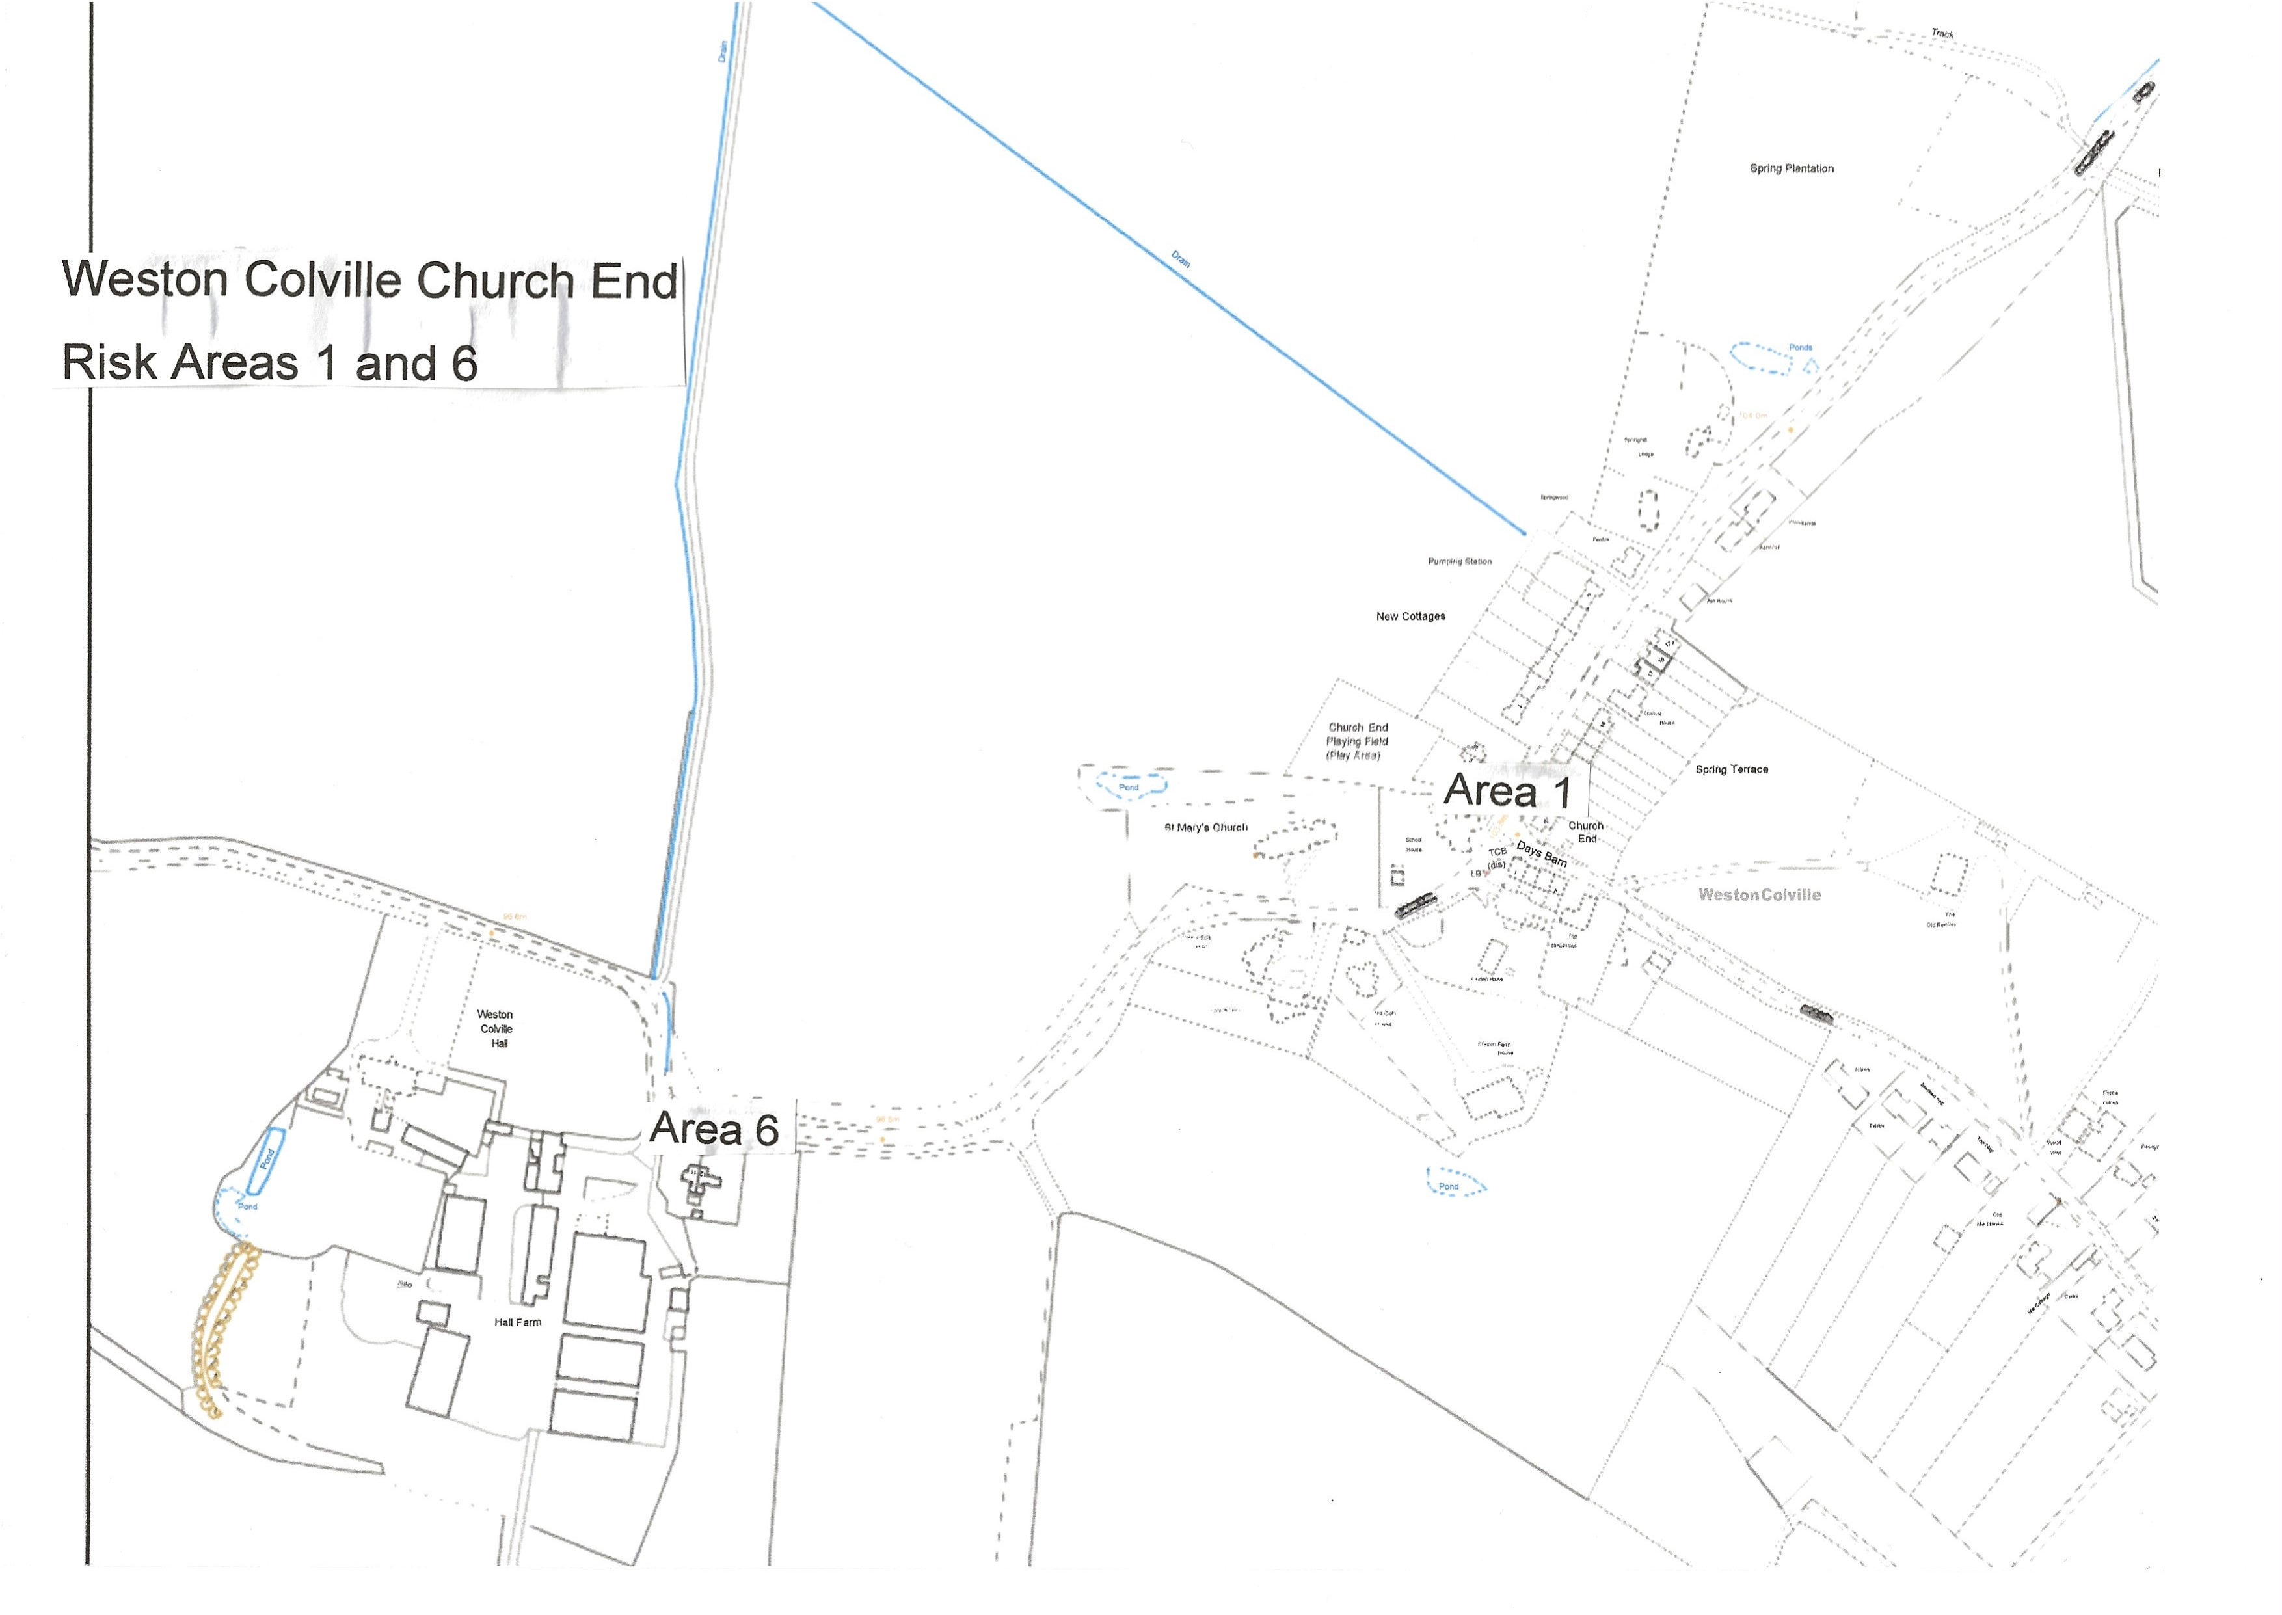

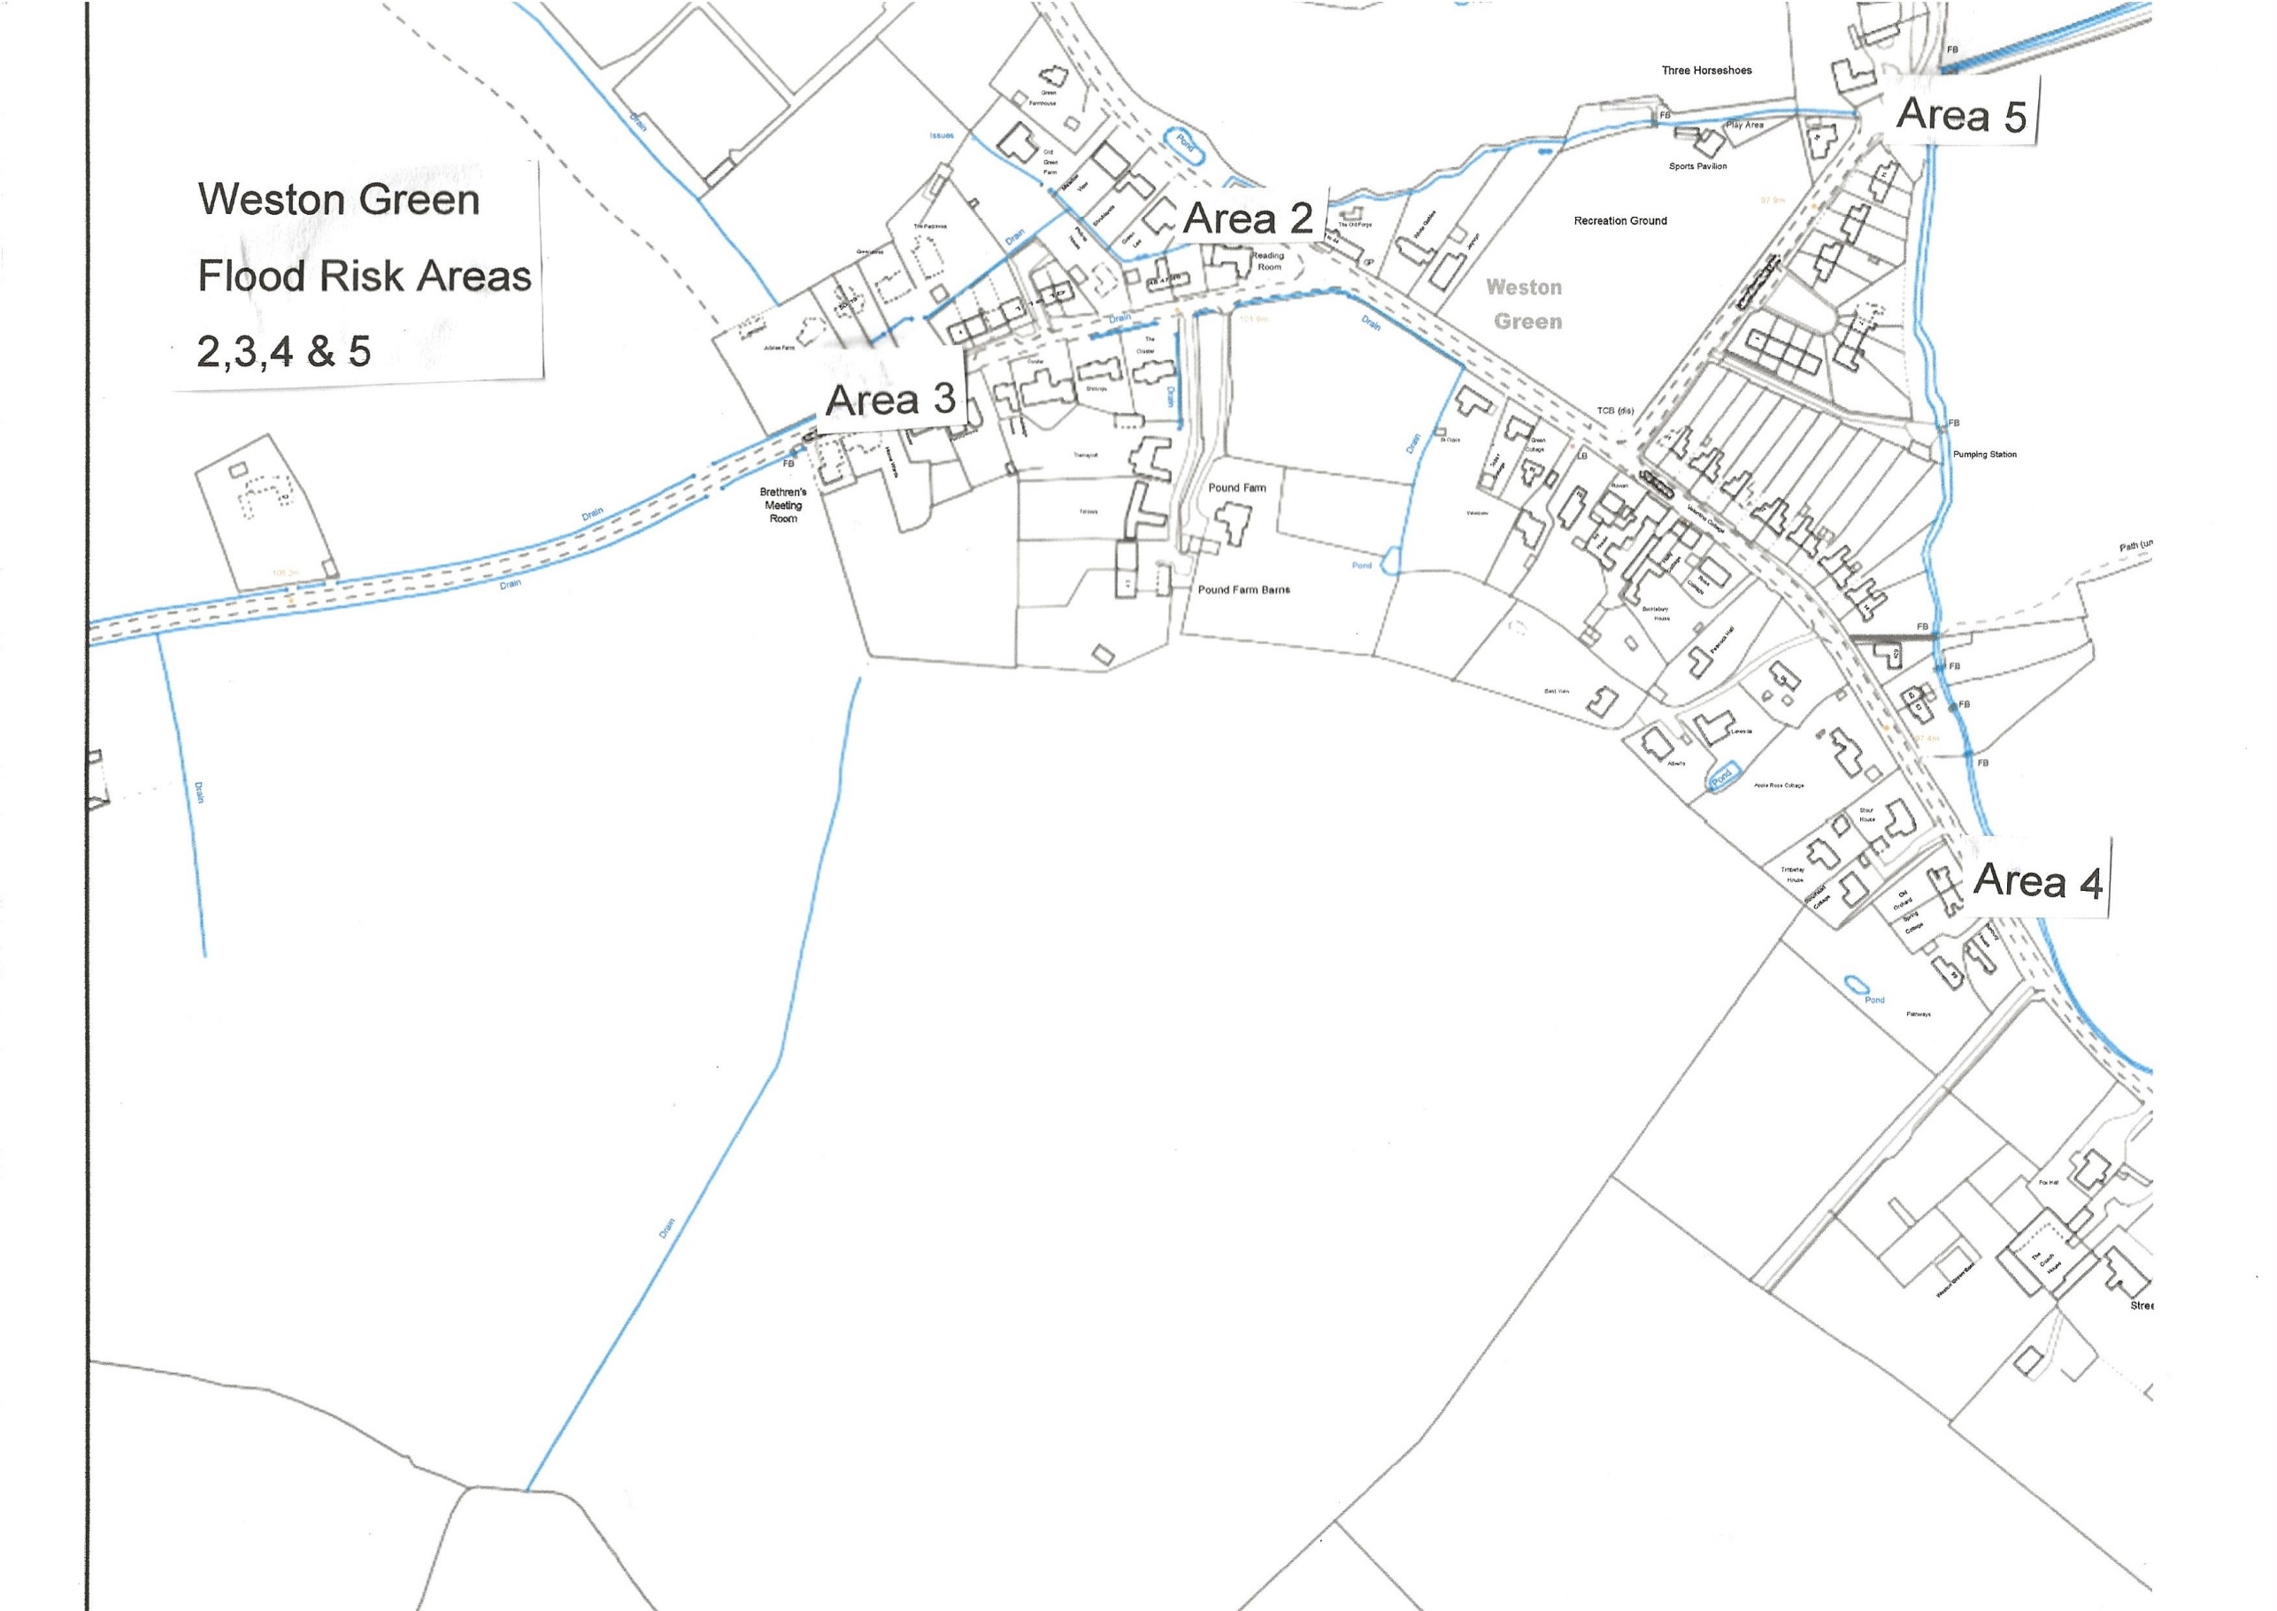

**2A – Actions to be taken during a flood:** local flood actions.

Identify local flood actions.

|  |  |  |  |  |  |
| --- | --- | --- | --- | --- | --- |
| **Area number** | **Location at risk** | **Action / trigger** | **Local action** | **Equipment required** | **Time required** |
| Area 1 | Church End/ New Terrace Cottages  Junction of Mill Hill and Brinkley Road | Water flowing down north side of Mill Hill and into Brinkley Road after persistent heavy rainfall. | Alert residents of problem including by local Flood Warden | Sandbags/hydrosacks – location to be determined. | At time of flooding incident  Sandbags available prior to flooding incident. |
| Area 2 | Area around the Reading Room – village end of Mill Hill and junction with Chapel Road. | Water flowing down south side of Mill Hill after persistent heavy rain. | Alert local residents of problem including by local Flood Warden.  Flood warning signs in position for motorists | Flood warning signs.  Sandbags/hydrosacks – location to be determined. | At time of flooding incident  Sandbags available prior to flooding events. |
| Area 3 | Chapel Road from Chapel to junction with Mill Hill | Water flowing down Chapel Road from west to east following persistent rain events. | Alert local residents including by local Flood Warden.  Flood warning signs in position for motorists | Flood warning signs  Sandbags/hydrosacks – location to be determined | At time of flooding incident.  Sandbags available prior to flooding incident |
| Area 4 | Common Road and local properties, particularly to the west of Common Road. | Road flooded after persistent heavy rain | Alert local residents of problem including by local Flood Warden.  Flood warning signs in position for motorists | Flood warning signs.  Sandbags/hydrosacks – location to be determined. | At time of flooding incident.  At time of flooding  Sandbags available prior to flooding incident |
| Area 5 | Clamps Lane/Horseshoe Lane Ford | Water level very high in ford area of Stour Brook | Alert local residents of problem including by local Flood Warden.  Flood warning signs in place for motorists | Flood warning signs | At time of flooding incident. |
| Area 6 | On B1052 at Church End just to the east of Hall Farm | Road flooded after persistent heavy rain | Alert local residents of problem including by local Flood Warden.  Flood warning signs in place for motorists | Flood warning signs | At time of flooding incident |

**2B – Actions to be taken during a flood:** local volunteers / flood wardens.

List local volunteers/flood wardens that could be contacted in an incident. They may be required to lift heavy sandbags so should be reasonably active or fit. Consider using other volunteers such as communicators, administrators, or minders of vulnerable people during an incident. These volunteers could be registered on the Environment Agency’s Floodline Warnings Direct service, so they receive the flood warnings. **Volunteers must not put their own life at risk.**

|  |  |  |  |  |
| --- | --- | --- | --- | --- |
| **Name** | **Address** | **Telephone Day** | **Telephone Evening** | **Mobile** |
| Ms I M Flooding | 213 Water Cottages |  |  |  |
| Mr U R Flooding | 276 Flood Alley |  |  |  |
| Dr Flood Warden | 76 Damp Ditches |  |  |  |
| Prof A N Other Flood | 1 The Puddle |  |  |  |
| Faye Parker? |  |  |  |  |
| John Garrod? |  |  |  |  |
| Bridget Durham? |  |  |  |  |
| Someone from Church End? |  |  |  |  |
|  |  |  |  |  |
|  |  |  |  |  |
|  |  |  |  |  |
|  |  |  |  |  |
|  |  |  |  |  |
|  |  |  |  |  |

**2C – Actions to be taken during a flood:** Important telephone numbers

Make a list of important telephone numbers so all the information you require during an incident is readily available.

|  |  |  |  |
| --- | --- | --- | --- |
| **Organisation** | **Telephone (office hours)** | **Telephone (out of hours)** | **Fax** |
| **Floodline** | 0345 988 1188 |  |  |
| **Environment Agency** | 0800 807060  Incident hotline |  |  |
| **District Council** | 03450 450 063 |  |  |
| **County Council** | 0345 045 5212 (Highways Agency for flooding issues) |  |  |
| **County Contracting** |  |  |  |
| **Fire & Rescue Service** | 999 |  |  |
| **Police** | 999 |  |  |
| **Ambulance Service** | 999 |  |  |
| **Housing Unit** |  |  |  |
| **Environment Unit** |  |  |  |
| **Water Company** | 01223 706050  Cambridge Water |  |  |
| **Electricity Company** |  |  |  |
| **Gas Company** |  |  |  |
| **Telecommunications Company** |  |  |  |
| **Adjacent Town/Parish Councils** | West Wratting  Brinkley  Carlton  West Wickham |  |  |

**2D – Actions to be taken during a flood:** Available resources

Identify available resources.

|  |  |  |  |  |
| --- | --- | --- | --- | --- |
| **Organisation** | **Resource** | **Number** | **Location** | **Notes** |
| Cambridgeshire County Council | The rights and responsibilities of a riparian owner | e-mail: floodand water@cambridgeshire.gov.uk |  | Leaflet available from Cambridgeshire County Council |
| South Cambs District Council for  sandbags/hydrosacks/aquasacks | It is recommended that property owners at risk of flooding make their own arrangements for sandbags/hydrosacks in advance of flooding. Residents can purchase sandbags and sand from builders merchants or DIY stores. You may also find further help from South Cambs District Council. Depending on the scale of flooding around the district, their resources may be seriously stretched and supplies of sandbags/hydrosacks may be limited and slow delivery timescales could be experienced. In an emergency situation, this service can be accessed by calling 03450 450 063 | 03450 450 063 |  |  |
| Water Gabriel | Flood Warden |  | Ambridge | No longer with us |
| Christine King | Trained First Aider | 01223 290963 | Tudor Cottage, The Green |  |
| Tracey Smith | Trained First Aider | 01223 290216 | Rose Villa, The Green |  |
| 4x4 owner/driver |  |  |  |  |
| Parish Defibrillator | All residents | Defibrillator code: C159X or call 999 with ID number of the device | Front of the Reading Room |  |
| Community Warden | Faye Parker | 07436 102865 | Stour House |  |
| Parish Church | Refuge/Safe Place | Ian Ashbridge, Church Warden 01223 291344 | Church End |  |
| Reading Room | Refuge/Safe Place | Peter Harris, Secretary  01223 290292 | Chapel Road |  |

**2E – Actions to be taken during a flood:** Arrangements between authorities

Details of specific arrangements between the various authorities to be included here.

|  |  |
| --- | --- |
| **Organisation(s)** | **Agreed arrangement** |
| County Council | Contacts: Henry Batchelor and Chris Green |
| South Cambs District Council | Contact: Geoff Harvey |
| Environment Agency | Contact: Floodline: 0345 988 1188 |
|  |  |
|  |  |
|  |  |
|  |  |
|  |  |
|  |  |
|  |  |

**2F – Actions to be taken during a flood:** Vulnerable residents, properties and locations

List vulnerable people, properties and locations where early assistance may be required.

|  |  |  |  |  |
| --- | --- | --- | --- | --- |
| **Name** | **Address** | **Daytime telephone** | **Evening telephone** | **Assistance required** |
| Area 1 | New Terrace Cottages, Church End |  |  |  |
| Area 2 | Properties mainly on the north side of Chapel Road but south side may also be at risk during severe weather events. |  |  |  |
| Area 3 | Bungalow and houses adjacent to the Reading Room up Mill Hill and the Old Forge |  |  |  |
| Area 4 | 1.Between Dove Cottage up to the area between No. 72 and Thoresby. This has been alleviated by work further down the Stour Brook, but the grips need to be recut once the CCC have worked out how to avoid the electricity cable.  2.From Fox Hall to Applerose Cottage. This flooding occurs in part when the Stour water level rises above the height of the roadside bank. There are grips cut there but they have the reverse of the desired effect. Highways Dept are aware but have yet to come up with a solution. |  |  |  |
| Area 5 | Area around the ford at Horseshoe Lane/Clamps Lane with risk of flooding to properties in the area. |  |  |  |

**3A – After a flood:** Reputable contractors

List companies/reputable contractors whose help you may need after a flood. Get contracts in place, or know who to call for assistance. If help is not needed, you can leave this section blank. If you plan to do the work yourself, leave this section blank.

|  |  |  |  |
| --- | --- | --- | --- |
| **Company name** | **Business (e.g. builder)** | **Telephone** | **Fax** |
|  |  |  |  |
|  |  |  |  |
|  |  |  |  |
|  |  |  |  |
|  |  |  |  |
|  |  |  |  |
|  |  |  |  |
|  |  |  |  |
|  |  |  |  |
|  |  |  |  |

**LIT 7488**